**Week 4: Moqup Task-2 https://app.moqups.com/Od7W7gc1TOV8jBSmD2grzVfmLs4zutsW/view/page/aa10d37ac** 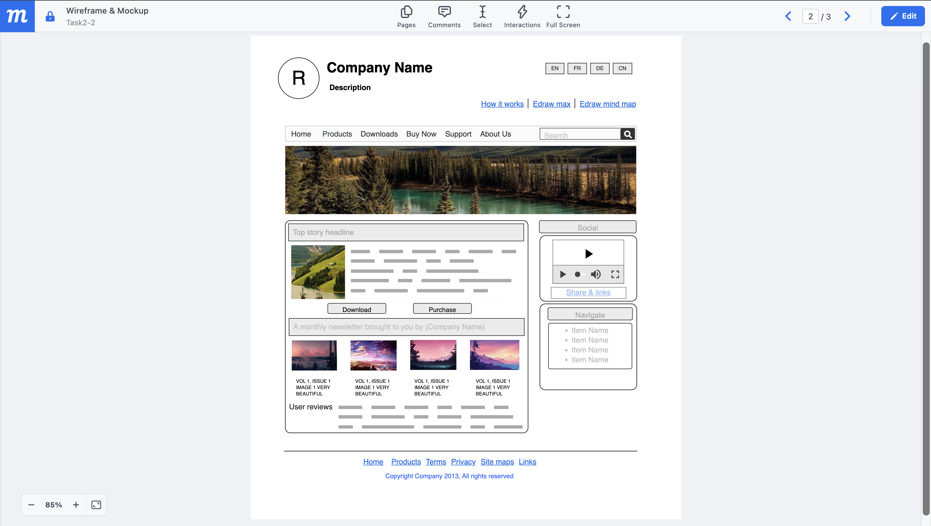

**Week 4: Moqup Task-3 https://app.moqups.com/Od7W7gc1TOV8jBSmD2grzVfmLs4zutsW/view/page/a09f9c**